PARANORMAL ARCHITECTURE | Ashley Davis

BACKGROUND | REFERENCES

1. The Overarching Brief: “In the ultimate project, Ecology of Place Interiority, experiments pose re-homing the un-homed in a 19th century education building deemed no longer fit for useful occupation, Domain House in Hobart. The studio exercises inform the parametically-derived re-occupation of the extant interior with the intent to model new, temporary living environments in existing spaces to facilitate making home in this city, currently experiencing a housing crisis.”
2. Previous examples of imagined (Interior) Places speculative exercise referencing Interiority and Home; Jack Halls (2019), Briener Yu (2019), Himali Jajal

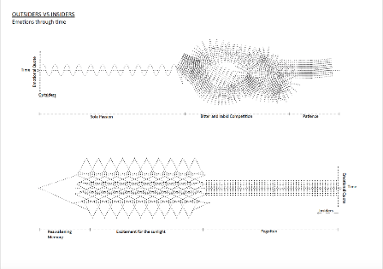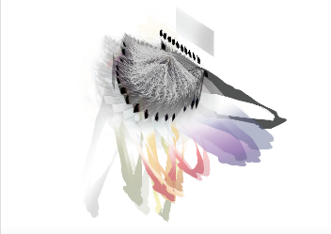

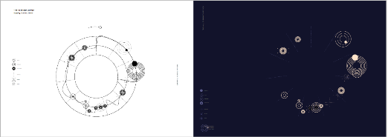

SITE | CONTEXT

1. [Macro] Hobat, Tasmania [lack of homing opportunities, gothic atmosphere, “troubled” past, growing future]
2. [Midi] Willow Court, part of the former Royal Derwent Hospital [tension between conservation and development, issues of maintenance/stewardship, “troubled” past, “unknown” future]
3. [Mirco] Interior spaces of the Women’s Cottage [Ward J] [[questions of temporal occupation [past/present], “troubled”past, “unknown” future]]

METHODOLOGY

1. MAPPING: To question the certainty of quantitative digital measuring, this project investigates the intentional use of broken, incomplete, or faulty technology, inspired by the tools of the paranormal investigator, to understand, map, or translate an existing historical space into architectural language.
2. LISTENING: Incorporating differing epistemologies, ones with the flexibility and capacity to acknowledge supernatural understandings of space, as a novel way to understand the tension between a “troubled” site and the realities of modern engagement with the place, both the tangible site and the intangible histories. This type of tourism is often called “dark tourism,” a reductive and conditioning term that may prevent the generational healing needed to reoccupy a “troubled” site.
3. DRAWING: To continue the conversation on the relationship between place and parametricism, this brief proposes to create new tools, faulty parametrics, to draw new para-spaces hidden between the our understandings of place and parametricism.

DELIVERABLES

1. Drawings mapping the paranormal experience of J Ward
2. Small writing provocation on supernatural spatial understanding evident in differing epistemologies and the strange benefit of faulty tools and their potential place in contemporary Western spatial understanding.
3. [Exhibition] Produce prototype drawing tools that demonstrate the research above

OUTCOMES

1. An attempt at an architectural understanding of an atmospheric space that inspires “dark tourism” could potential lead to a better understanding of placemaking in general.
2. Differing but parallel epistemologies could bring a freshness to the conversation on reoccupying or engaging with “troubled” spaces with real world implications to tourism, development, maintenance, and the economics of the site.

PRECEDENTS

1. Harvey Moon, Sinue, Bugs Draw

<https://www.youtube.com/watch?v=VufMgHvaoG0>

<http://harveymoon.com/>

1. Alan Storey, Climatic Drawing Machine

<http://www.c4gallery.com/editions/alan-storey/alan-storey-climatic-drawing-editions.html>

1. Cameron Chaney, Audio Responsive

<https://www.creativeapplications.net/member-submissions/sensory-responsive-drawing-machine/>

PERSONAL WORK



